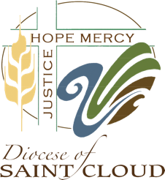
2021 – 2022 Continuing Formation Request
& 2022 – 2023 Planning

Date: / /
Deacon Name:
Parish Assignment:
REPORT OF CONTINUED EDUCATION FROM July 1, 2021 – June 30, 2022
“Each deacon will be required to fulfill at least twenty hours of activities each year.”

DATE(S) | COURSE TITLE (Conference, Workshops, etc.) | HOURS
 | TOTAL CONTINUING EUCATION HOURS:

CONTINUING EDUCATION PLAN FOR 2022 – 2023
Please list goals and activities, workshops/conferences, etc. your planning to reach your goals:
TOTAL CONTINUING EUCATION HOURS:

Please return electronically or by mail by October 1st:
Office of the Diaconate
Deacon Personnel Board
305 North 7th Avenue
St. Cloud MN 56303
jjacobs@gw.stcdio.org

